# CS 340 README

**Grazioso Salvare Dashboard**

The Grazioso Salvare dashboard is a dashboard created using python to allow users to easily identify suitable candidate dogs for their training programs. The dashboard is built using the dash framework in python, and uses a custom Create, Read, Update, Delete (CRUD) engine which is also built using python.

To identify the suitable dogs for a particular rescue operation, simply select the desired rescue operation from the dropdown. Select “all” to show all animals currently in the AAC database.

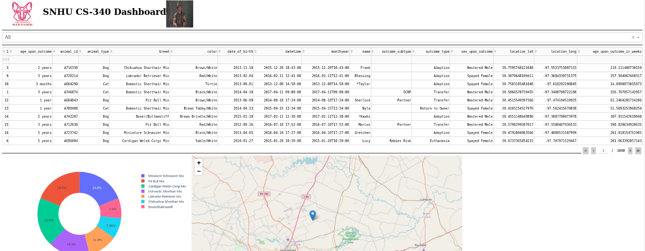

Select “water rescue” to see dogs that would be suitable for water rescue missions

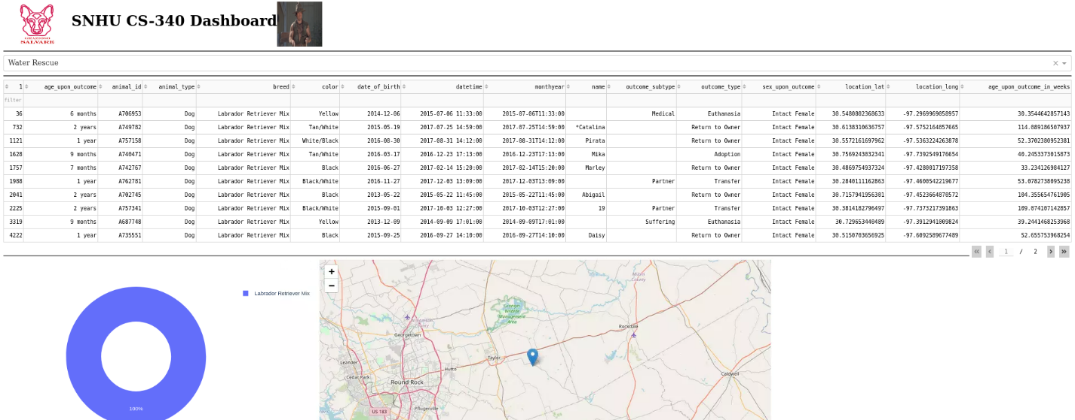

Select “Mountain or Wilderness Rescue” to show the dogs that would be suitable for remote rescue operations

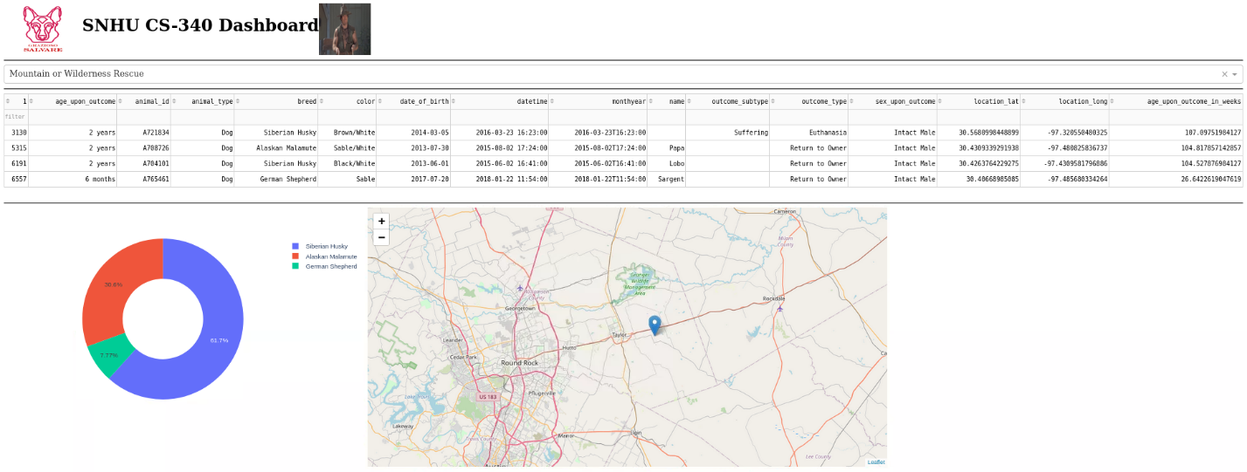

Select “Disaster Rescue” for dogs that would be suitable for disaster rescue operations

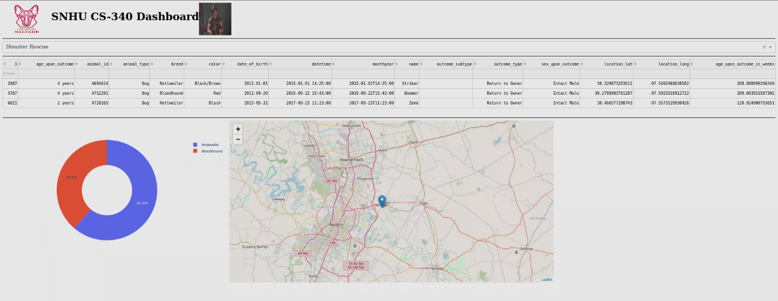

**Tools**

The dashboards and widgets were built using Jupyter. Juypter allowed for easy integration into the CRUD python script, and allowed for quick iterations and easy testing.

The database of animals housed by the AAC was built using MongoDB. MongoDB was selected as it was easy to interface with python using the pymongo module.

The UI elements were created using the dash framework within python. Dash provides for easy UI styling with html and callback functions to style the data in a user-friendly format. Additionally, the pie chart and map widgets were built using the dash graph and Map methods, respectively.

**Explain the steps that were taken to complete the project.**

To complete this project, I first created the CRUD controller script which will connect to the MongoDB instance housing the AAC animals collection, and perform create, read, update, and delete operations using the mongodb APIs. Then I created the UI dashboards/views using dash to connect to the CRUD controller. I then ensured that the dashboard was meeting all of Grazioso Salvare’s requirements.

**Identify any challenges that were encountered and explain how those challenges were overcome.**

During project 2, I encountered an error where the command line said that Mongodb was already running. This caused my dashboard to fail to connect, which didn’t allow me to test my code at all. I tried several methods to fix the issue, including rebooting the virtual machine and killing the mongodb process. Eventually the mongodb instance stopped and I was able to start it again without issue.

I additionally faced an issue where the graph wasn’t showing up. I discovered that the cause of the issue was that the inputs and outputs supplied to the callback were using double quotes instead of single quotes. Once I fixed this, it worked without any issues.

## Contact

Your name: Becky Scott